Children - props

Implementation is pretty simple. In the parent component, import the child component, but instead of invoking it with a self-closing tag, use an standard open/closing tag. The information that you want to pass through props — in addition to the standard implementation of passing props — is placed between the opening and closing tags of the child component.

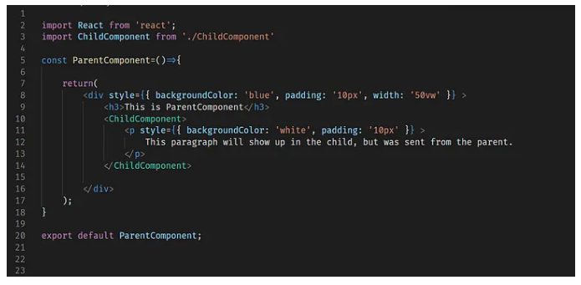

**Implementing <ParentComponent />**: The <ParentComponent /> defines a paragraph that will be passed down to the <ChildComponent /> as props.

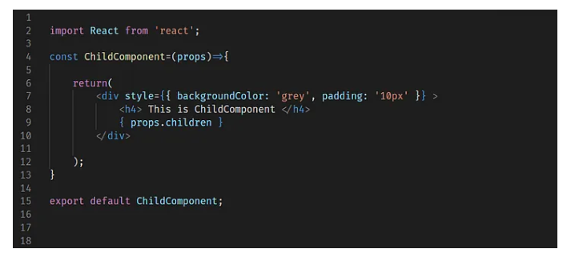

**Implementing <ChildComponent />**: In the ChildComponent. { props.children } will render any data that has been passed down from the parent, allowing the ParentComponent to customize the contents of the ChildComponent.

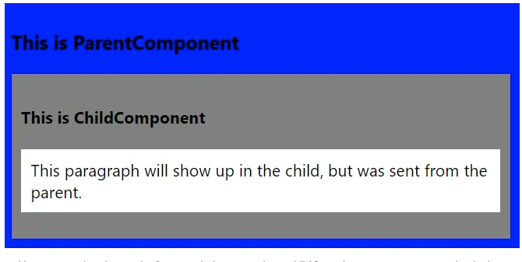

Example

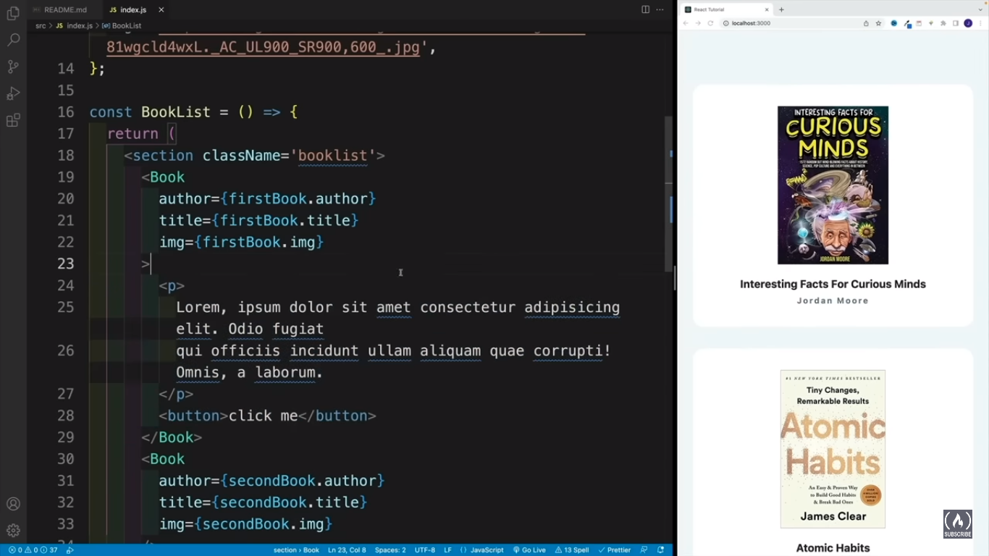

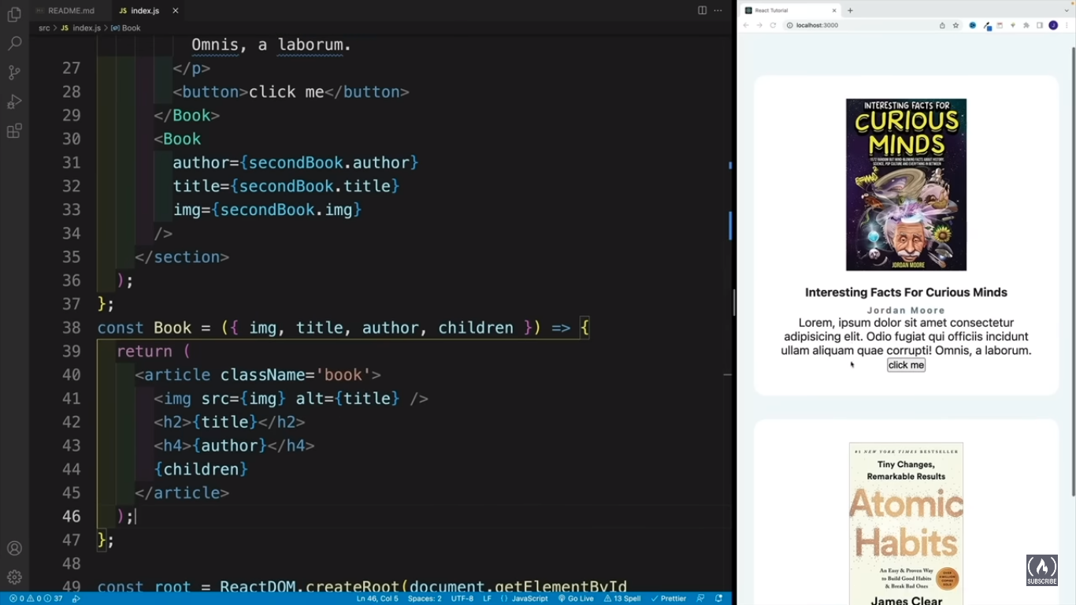

Using props

